Age of Empires II the Board game.

Game Components
Board pieces
- Board outline
- 34 tree tiles, 8 gold tile, 8 stone tiles, 119 grass tiles, 56 water tiles.
- 60 hp tokens ranging from (1 – 6) 10 of each
- 4 player boards with 4 income tokens (indicating 50 or 100) to help keep track of each resource gathered. As well as which age everyone is in.
- 64 resource tokens for player boards indicating +1000 to +4000
- 6 dice – 3 defender dice and 3 attacker dice
- 340 army pieces
  - 100 archers
  - 100 knights
  - 100 swordsmen
  - 12 castles
  - 8 town centers
  - 20 outposts
Setting up the game
Choose your Civilization
- Players should choose from one of the unique factions that give special bonus for playing that civilization
Organize your resources.
- Go ahead and organize the resources. Each player should start with 1000 food,1000 wood, 500 gold, and 300 stone.’
Setup the board
- Go ahead and setup the board, choose one of the default boards, take turn placing pieces, or just randomly throw pieces together to create your “Map”
Choose starting positions
- Each player after the board is set should take turns placing one Town Center to signal their starting positions. Town centers must be at least five moveable tiles from each other. Afterwards players may place 3 infantry, 2 archers, and 1 knight on or one tile away from their town center.
Choose who goes first
- The youngest player goes first and chooses who goes last. When playing with four players the remaining two roll for 3rd and 4th.
Buildings
Age of Empires has a few buildings you can build either to increase resource gain or better your defense.
Castles
- Castles are strong defensive buildings. Castles get a volley at the same time archers do with the same requirements to hit but as a separate attack and always with 2 dice. Castles can also store two archers acting as infantry should no other units be left. Castles have 6 hit points indicated by a token underneath it. Castles cost 800 wood, and 500 stones. Castles may not be built on gold or stone tiles and may only be built after the first age.
Town Centers
- Town centers are your main structures. Should you lose all your town centers you lose the game. Town centers must be 5 moveable tiles apart They also generate food, and wood if it is on a tile adjacent to a forest. Town Centers cost 500 wood and 300 stone. Town Centers may act as mini castles, being able to store one archer and having 3 hit points indicated by a token underneath it.
Outpost
- Outposts are small collection points for resources. A player can use outpost to gather from gold or stone tiles. An outpost can also collect wood so long as its adjacent to a wood tile. Outpost cost 300 wood and 150 stone
Structure destroyed or lost.
- Castles and Town centers must be attacked to be destroyed. Outposts are automatically destroyed if an enemy is on the tile with no ally forces to defends it.
Resources
Age of Empires has 4 different resources. Food, Wood, Gold, and Stone. Depending on which units you want to create depends on which resources you have stored. Resources are generated once per round when it becomes your turn.
Food
- Food is collected by having a town center. Each town center generates 500 food per round. (This amount will increase as you advance through the ages.)
Wood
- Wood is collected by have a territory with a town center or Outpost adjacent to any wood tile. Each wood tile gives a set amount of wood staring at 200 per tile. (This amount will increase as you advance through the ages.)
Gold/Stone
- Gold/Stone is collected by having an outpost or Town Center constructed on a tile with a gold/stone mine. Each gold mine gives 300 per tile. Each Stone mine gives 100 per tile (This amount will increase as you advance through the ages.)

Units
Age of Empires has 3 different units that each have their own use. You have Swordsmen, Archers, and Knights.
Swordsmen
- Swordsmen are your standard infantry costing 100 food and 100 gold they attack normally.
Archers
- Archers are a support infantry costing 150 wood and 100 food, and they get to attack before the Infantry charge (Both sides get to roll 2 dice and need to roll a 4 or higher to hit) Players get to choose whether they target infantry or enemy archers.
Knights
- Knights are your heavy hitters, costing 200 food and 200 gold. They get 3 movement when Mobilizing/Maneuvering. Knights also get the ability to charge. Once per battle up to 2 knights for both sides may charge the enemy archer lines or infantry. This happens after the archers attack and before the infantry charge/attack. Both attackers and defenders need to roll a 4 or higher for a knight to kill an archer and a 5 or higher to kill an infantry unit. When charging archers if a knight fails to roll a 4 or higher consider them stopped by infantry and “Locked in combat” the knight now acts as an infantry unit. Knights that charge infantry are always “Locked in combat” after they roll. Knights not “Locked in combat” are considered roaming, unable to be attacked.
On Your Turn
- Collect resources: Count the resources you should collect and grab from the bank
- Train units and build structures: Units must be placed at either a town center or Castle, Structures can only be built on tiles with a unit present.
- Mobilize Units: Go ahead and move your units around the board. Units cannot move onto forest or water tiles, remember units that moved during this phase cannot move during the maneuver phase.
- Invade: Choose any tiles you want to invade
- Maneuver: Move any other units around the board.
Invading and Combat
Age of empires has combat like Risk with a few differences for each unit.
- The players who turn it is, declares an invasion choosing a territory to attack. Both territories need to be connected.
- The attacking players chooses what units he is attacking with amassing them on the enemy territory
- Players roll dice for each unit in battle up to 3 for the attacker and 2 for the defender. (With some exceptions check Units for more details) Depending on what units each army has determines how they roll. First roll for archer’s volley attack, then roll for Knight charges, and lastly the infantry fight. Remove units immediately after each attack.
- Pair up the attack and defense dice in order from highest to lowest. Then, compare the pairs.
  - If the attack die is higher than the defense die, the defender loses a unit.
  - If the defense die is higher or equal to the attack die the attacker loses a unit.
  - Both sides get to choose their casualties. So, if the defender has 3 Swordsmen and 1 knight “Locked in combat” and the attacker scored 3 hits, the defender can choose to either have 3 Swordsmen die, or 2 Swordsmen and 1 Knight.
- Repeat this step for the next highest die on both sides.
  - Any hits that would exceed the number of units you are targeted can be considered as misses. So, 3 hits against a single infantry doesn’t apply any excess to the archer line or roaming Knight units.
  - Should a player have no infantry to engage in the infantry attack they must designate either some remaining Knights or archers to act as infantry. Each side must have at least two infantry units per to fight. Archers acting as Infantry no longer get to shoot a volley and have -1 to their roll. Knights are considered “Locked in Combat”.
  - Should an army consisting of only archers attack or be attacked, they get one volley before having to designate some as infantry.
- After completing steps 1-5 either player may choose to retreat, so long as both sides have an empty or friendly tile adjacent to where combat took place. But the player retreating must leave 2 defenders behind to act as infantry and cover the retreat. These two units never get the chance to retreat.
Advancing through the Ages
In Age of Empires advancing through the ages increases the resource each player gets, affecting the scale of the game. The first age increases the resource collection by 50%. The second age increase resource collection by 33%. So, after the first age, each wood tiles generates 300 wood, each gold mine generates 450 gold, each stone mine generates 150 stone, and each town center generates 750 food. Round to the nearest 100th or 50th place. Advancing to the next age does not increase resource gain from faction specific bonus. This includes (The Franks castles, the celts outpost, and the Vikings plunder ability)
Advancing through the ages only happens twice and is different for the number of players playing.
2 players
- The first age happens after 6 complete turns for each player (12 turns total)
- The second age happens 8 complete turns after the first (16 turns total)
3 players
- The first age happens after 5 complete turns for each player (15 turns total)
- The second age happens 7 complete turns after the first (21 turns total)
4 players
- The first age happens after 4 complete turns for each player (16 turns total)
- The second age happens 6 complete turns after the first (24 turns total)
Civilizations
Franks
The Franks are a strong kingdom descending from Germanic tribes in modern day France, previously known as Gaul. As time went on the Franks would develop into the Kingdom of France develop a strong nation with powerful knights at the core of its military.
The Franks focus on cavalry and food production. Their knights have increased movement from 3 to 4, and each castle they have gives them an extra 100 food and 50 gold. Allowing them to move around the board faster and produce more food focused units.
Japanese
The Japanese was an isolated Kingdom both my Geography and by choice. Yet, when exposed to outside technology they were able to adapt extremely well and in a very short amount of time. The nation of Japan developed a strong military class known as the Samurai. They had a strict bushido code and went through years of training.
The Japanese focus on infantry and cheaper buildings. At the start of their turn the Japanese get one free infantry unit at any castle they own, and a free archer should they have two or more. (Extra castles do not give any extra units beyond 2). Also, their outposts cost 150 less wood.
Britons
The Britons was a strong nation that constantly spread from their isolated island of Great Britain. Even though they live on an island much smaller than Europe, their military campaigns were extremely successful, and their nation became very powerful. Many of their campaigns made use of the English Longbow giving them superior range and accuracy for their archers.
The Britons focus on Archers and unique outpost. Their first two archers they create per turn cost 50 less wood and any outpost they create can act as a Watch Tower, being able to garrison two archers, protecting them from enemy volleys. The outpost has no HP, and the archers are vulnerable to infantry attack when being the last two units on the tile.
Celts
The celts are a mixture of Scotland, Ireland, and wales traits. While remaining close to the Britons they developed their own culture and their own tactics. They were successful raiders and were known to have impressive wood and metalworking.
The celts focus on wood and quick infantry deployment. Every outpost generates a bonus 50 wood. Regardless if next to a forest tile or not. The Celts can also deploy up to 2 infantry units to any outpost as if they were deploying to a castle or Town center.
Vikings
The Vikings were feared warriors that spread terror wherever they raided. Their men would refrain from shaving their beard to make them look more like hairy beast. They were also some of the first people to settle outside Europe years before other European countries.
The Viking’s strength lies in their raiding and unstoppable infantry. If a Viking player conquers any building from a player, they may still a combination of 500 resources. (Max 200 per resource). The Vikings may also “Resurrect” one infantry unit so long as two or more died during their turn. (only once per their turn)
Persians
The Persians are a Middle Eastern Civilization. With many of the empires located along the great trade routes, the Persians prospered from great amounts of trade and culture learning. With being a center of trade, the Persians developed interesting military tactics to defend their cities, including using elephants.
The Persians get bonus resource per age. The first age gives 300 of each resource, while the second age give 500 of each. They also have stronger town centers to reflect their trade status. Each town center has one extra HP compared to other civilizations.
Game Board example
The game board can be set however the players want, but for a balanced experience please refer to the image below.
Black forest
There are four locations with equal access to resource and plenty of chokepoints formed by the forest to hold back your opponents.
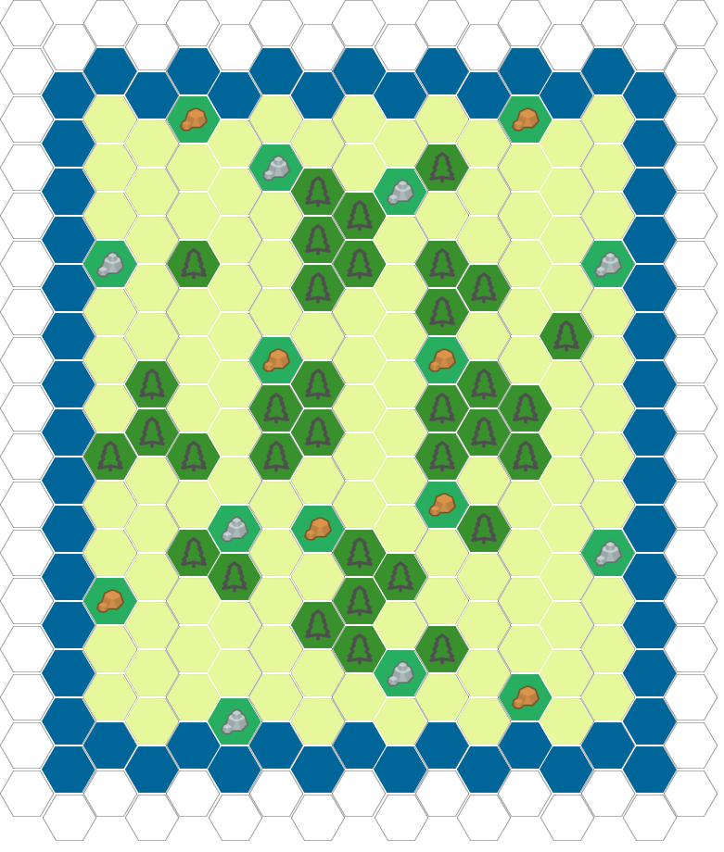

Oasis
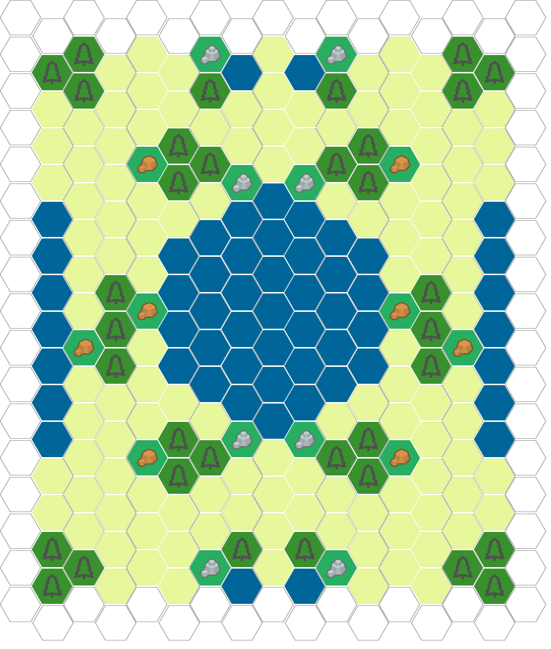
Similar to the Black Forest, Oasis provides four equal locations, but your gold and stone further tend to be further away and harder to defend. Still, plenty of choke points should you hold the proper routes

History
The Franks
The franks were one of the Germanic barbarian tribes know to the Romans. In the fifth century they expanded south from their homeland along the Rhine. Now unlike many other tribes they did not abandon their homeland but added to it as they expanded. Clovis, a Frankish chieftain would unite the franks to defeat some of the final Roman armies. From this would form the early beginnings of the nation of France.
Clovis’ sons would inherit his lands, divided amongst them. This led to many years of civil wars. After many years later descendants of Clovis would be nothing more than figure heads. Charles Martel was the ruler behind the throne, and the one responsible for turning the Franks into a fearsome Cavalry force. His forces defeated Muslim invades stopping the advance of Islam.
Charles Martell’s Son Pepin would later become king of France by the pope’s order, for defending against the Lombards. This dynasty would be called the Carolingians. The greatest ruler from this line was Charlemagne who expanded much of the Kingdom molding it into an empire. Still, like before his descendants would fight a civil war splitting the kingdom yet again.
The Franks would continue to both struggle and grow from war and political weakness plagued them. Yet, after the hundred-year war with Briton, France would unite and remain a strong nation within Europe.
The Japanese
Japan was a mysterious land at first. Isolated both by geography and later by choice. They developed a distinct culture. Even still the island of Japan had different cultures that would fight and unite to form the nation of Japan.
In the early years of Japan power was giving to lords and clans who while they all answer to a Shogun, still strive for power and land over each other. Meanwhile the emperor oversaw more spiritual and religious purposes.
From Mongol invasions and inter conflict the Japanese Samurai was formed. Powerful warriors who whole life was dedicated to training the body and mind. The samurai were noble and extremely loyal to their lords. These warriors would defend their lords to the last and would show little cowardice in battles.
The land of Japan would remain a mystery for many years as other countries tried to explore and seek trade with the island Nation, yet many would be ignored or forced out.
The Britons
The British Isles fell under a dark time with the withdrawal of the Roman legion, with almost no written records surviving. During this time tribes from Ireland and Europe would travel to the island. The Saxons and angles from Germany would travel and control most of what is modern England today.
Later Forming the Anglo-Saxons and calling the land England also from the combination of Angle-land. They also brought over the language of English replaced the Latin and Celtic language previously.
England would not have peace for long once the Danish Vikings invaded. Conquering all but one kingdom. This kingdom under Alfred the great. Now divided the Danes would collect taxes until the English turned against them driving them out once and for all uniting England for the first time.
England enjoy power and peace for many years within their own land but sought to expand and seek power elsewhere. One example was the hundred-year war with France, where England claimed parts of France as their own. The English would have the upper hand for most of the war, yet ultimately would loose giving up all hold to French land.
The celts
The celts would share much of the same land and fate as the Britons. They fought aggressively with the Roman but ultimately were forced back to what is now Scotland and Ireland today. After which they would struggle against the English. The celts would also have to deal with the same Viking raids the English did, but ultimately, they would kick them out of Ireland.
In a weird similarity a Irish tribe called the Scotti would invade the area of Scotland, settling there giving the land its name. While somewhat independent they would have constant conflicts with the British. One of these revolts led by William Wallace (Braveheart) began many years of war from the early 1300 till about 1603 when the lands were united under one King.
The Vikings
The Vikings were some of the last barbarian tribes who would terrorize Europe. From their homeland in Scandinavia, they would strike suddenly from the sea on their longboats, raiding and pillaging towns along the coast. Most of the time they would withdraw before any real opposition could be formed. Yet they did manage to conquer much of Europe at one point.
Being shipwrights and sailors allowed them to travel quickly across long distances. They would discover and settle in areas like Iceland, Greenland, and some believe areas of north America, way before Columbus.
The Vikings would raid many countries and lands including Russia, England, Germany and France. Sometime full-scale invasions other time small raids. They would even set up camps for future raids. Eventually as the Viking lands developed and Christianity took hold the raids would stop as the kings focus on running their countries.
The Persians
The Persian emperor was a assembling of kingdoms following Alexanders conquest around the fourth century BC. And like many of the other civilizations they would fight against the Romans for years. Although the Romans made many attempts to subdue the Persians, they ultimately signed a treaty allowing the Persians to focus elsewhere.
With peace from the Romans, they strengthen their empire before beginning war with the Byzantine empire. The war went back and forth till both empires exhausted from warfare made peace. Shortly after the Islamic Arabs invades and Persians was unprepared for the strength they brought. Within 20 years the Persian empire was conquered and under Muslim control.

